July 24P^{th}P, 2021  Local Authors, Artists, & Actors Day  0BYOUR CONTACT INFORMATION:  Name: ________________________________________  Description of Work: ______________________________  Street Address: __________________________________  City, State, ZIP: __________________________________  Home Phone: ___________________________________  Cell Phone: _____________________________________  E-mail Address: __________________________________  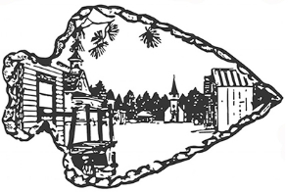  OR Submit this information via e-mail at 44TUAdmin@PioneerVillageMuseum.onmicrosoft.comU44T | 1BThe Barron County Historical Society would like to invite you to participate in our fourth annual Local Authors, Actors & Artists Day. This is a chance to meet the public and display and sell your published works or original pieces of art.  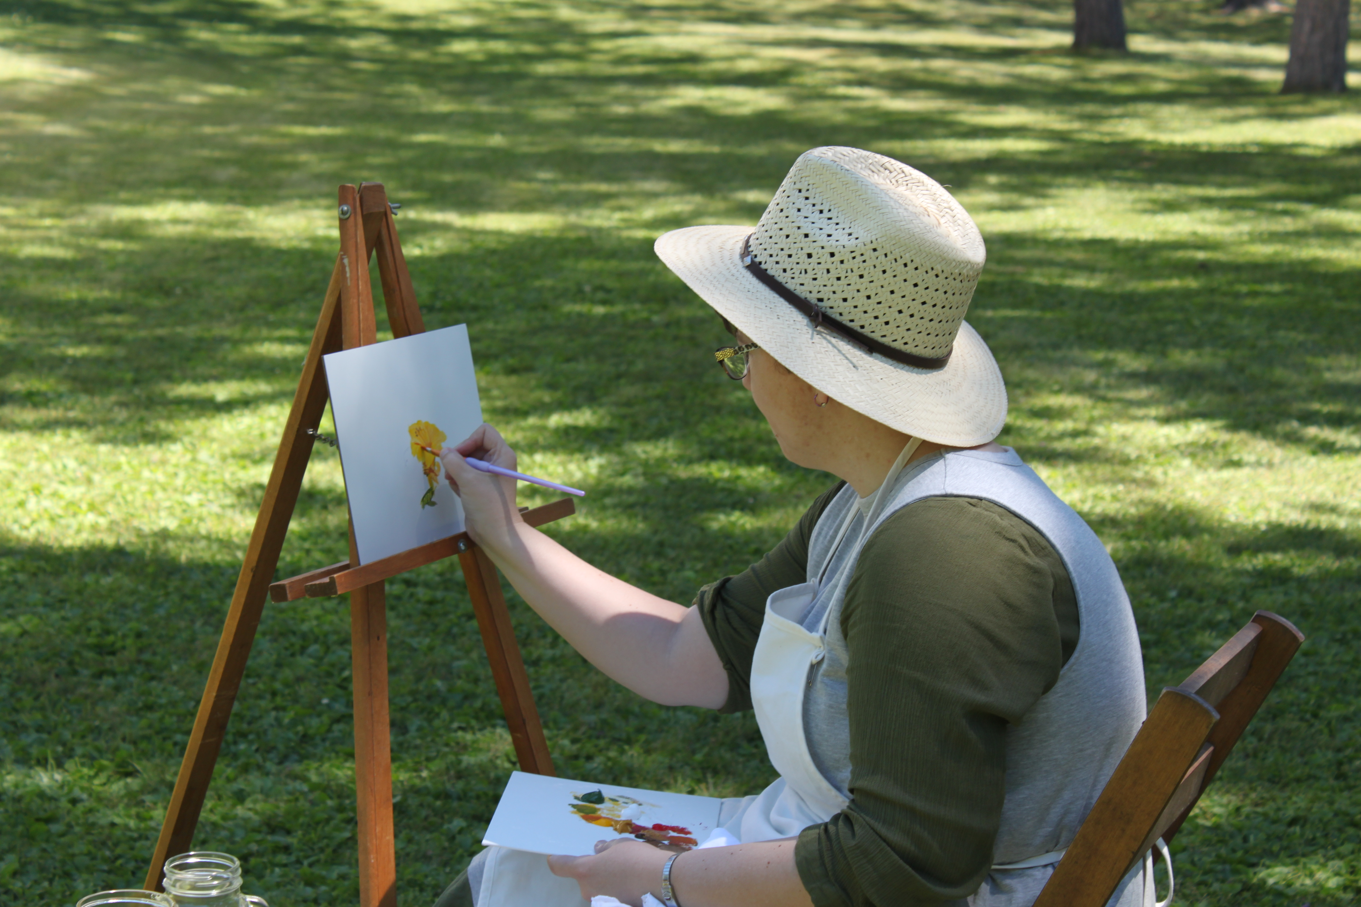  2Throughout the day, various authors, actors, and artists will be taking the stage to talk about their craft, do short readings, and otherwise engage the audience.  ────  4BThere is no charge to participate. You are welcome to sell directly to the public and autograph your work.  5BPioneer Village Museum  PO Box 242  Cameron, WI 54822  715-458-2080  pioneervillagemuseum.org  July 24, 2021: 10AM-5PM

